
INFI SENSE
Practical approach to IoT
User manual
version-1.0

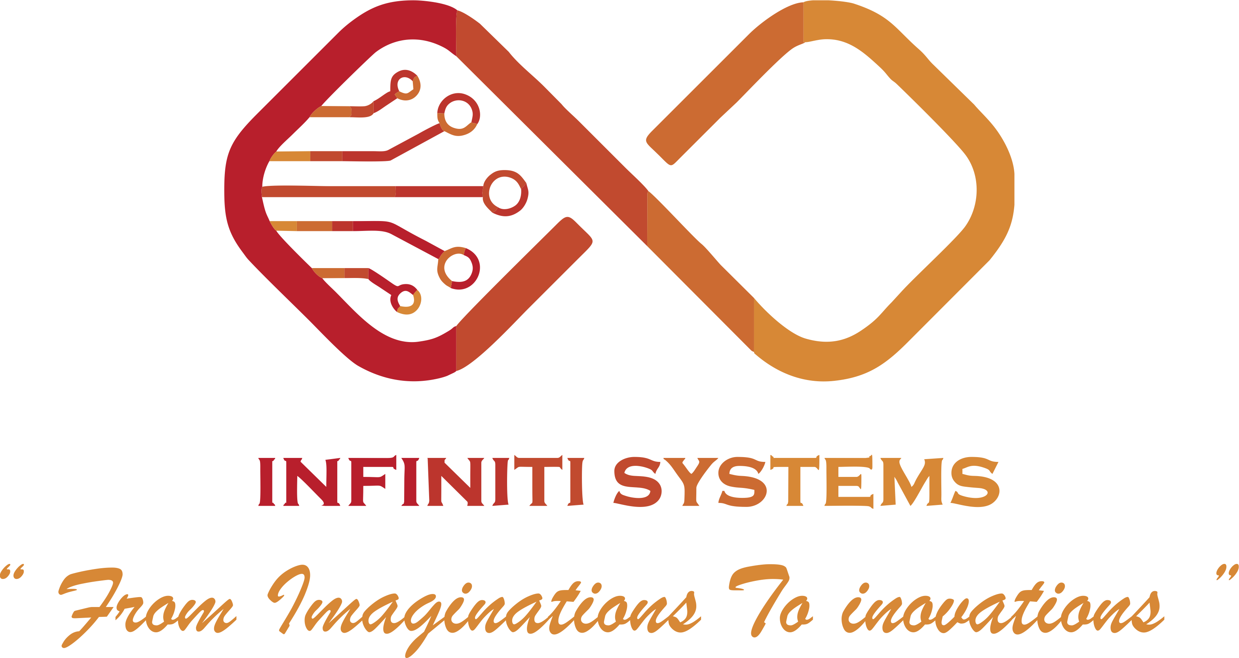

INFINITI SYSTEMS, Pune
Web:-www.infinitisystems.co.in
Email-Id:-info@infinitisystems.co.in

About Company
Infiniti Systems is a spinoff associate of Ni Logic Pvt. Ltd. founded on a culture based on the principles of open communication, empowerment, trust, integrity and giving back to the community, and these same values thrive at Infiniti Systems today.
Infiniti Systems family brings together a rich experience across all domains of IOT, Robotics, Embedded Systems, PCBs and Rapid Prototyping. We design and develop custom solutions, reverse engineer aged products, offer training solution, etc.

Table of Contents
Preface Error! Bookmark not defined.
1 Introduction Error! Bookmark not defined.
1.1 Block Diagram Error! Bookmark not defined.
1.2 Features Error! Bookmark not defined.
1.3 Specifications Error! Bookmark not defined.
1.4 Applications Error! Bookmark not defined.
1.5 Supported Sensors Error! Bookmark not defined.
2 Let’s Record Error! Bookmark not defined.
3 Writing Config File Error! Bookmark not defined.
4 Connecting Inputs Error! Bookmark not defined.
4.1 Interfacing high voltage Error! Bookmark not defined.
4.2 Interfacing 4-20ma Current Loop Error! Bookmark not defined.
5 Plotting Results Error! Bookmark not defined.
6 FAQs Error! Bookmark not defined.

What is IoT?
The internet of things, or IoT, is a system of interrelated computing devices, mechanical and digital machines, objects, animals or people that are provided with unique identifiers (UIDs) and the ability to transfer data over a network without requiring human-to-human or human-to-computer interaction.
The definition of the Internet of things has evolved due to the convergence of multiple technologies, real-time analytics, machine learning, commodity sensors, and embedded systems. Traditional fields of embedded systems, wireless sensor networks, control systems, automation (including home and building automation), and others all contribute to enabling the Internet of things. In the consumer market, IoT technology is most synonymous with products pertaining to the concept of the "smart home", covering devices and appliances (such as lighting fixtures, thermostats, home security systems and cameras, and other home appliances) that support one or more common ecosystems, and can be controlled via devices associated with that ecosystem, such as smartphones and smart speakers.

Def 2
Internet of Things (IoT) is an ecosystem of connected physical objects that are accessible through the internet. The ‘thing’ in IoT could be a person with a heart monitor or an automobile with built-in-sensors, i.e. objects that have been assigned an IP address and have the ability to collect and transfer data over a network without manual assistance or intervention. The embedded technology in the objects helps them to interact with internal states or the external environment, which in turn affects the decisions taken.

About the Product

Controller
ESP8266-12E
NodeMCU is an open source IoT platform. It includes firmware which runs on the ESP8266 Wi-Fi SoC from Espressif Systems, and hardware which is based on the ESP-12 module. The term "NodeMCU" by default refers to the firmware rather than the development kits. The firmware uses the Lua scripting language. It is based on the eLua project, and built on the Espressif Non-OS SDK for ESP8266. It uses many open source projects, such as lua-cjson and SPIFFS.

Sensors
UV: ML-8511
The ML8511 is a UV sensor, which is suitable for acquiring UV intensity indoors or outdoors. The ML8511 is equipped with an internal amplifier, which converts photo-current to voltage depending on the UV intensity. This unique feature offers an easy interface to external circuits such as ADC. In the power down mode, typical standby current is 0.1A, thus enabling a longer battery life.
Light Intensity: BH-1750
BH1750FVI is a digital Ambient Light Sensor IC for I2C bus interface. This IC is the most suitable to obtain the ambient light data for adjusting LCD and Keypad backlight power of Mobile phone. It is possible to detect wide range at High resolution. (1 - 65535 lx).
Soil Moisture

Soil Temperature: DS18B20
The DS18B20 digital thermometer provides 9-bit to 12-bit Celsius temperature measurements and has an alarm function with non-volatile user-programmable upper and lower trigger points. The DS18B20 communicates over a 1-Wire bus that by definition requires only one data line (and ground) for communication with a central Microprocessor. In addition, the DS18B20 can derive power directly from the data line (“parasite power”), eliminating the need for an external power supply.

Rain Drop Sensor
Leaf Wetness Sensor

Air pressure, Humidity & Temperature: BME 280
The BME280 is as combined digital humidity, pressure and temperature sensor based on proven sensing principles.
The BME280 achieves high performance in all applications requiring humidity and pressure measurement. These emerging applications of home automation control, in-door navigation, health care as well as GPS refinement require a high accuracy and a low TCO at the same time.
The humidity sensor provides an extremely fast response time for fast context awareness applications and high overall accuracy over a wide temperature range.

The pressure sensor is an absolute barometric pressure sensor with extremely high accuracy and resolution and drastically lower noise than the Bosch Sensortec BMP180.
The integrated temperature sensor has been optimized for lowest noise and highest resolution. Its output is used for temperature compensation of the pressure and humidity sensors and can also be used for estimation of the ambient temperature.
The sensor provides both SPI and I²C interfaces and can be supplied using 1.71 to 3.6 V for the sensor supply VDD and 1.2 to 3.6 V for the interface supply VDDIO. Measurements can be triggered by the host or performed in regular intervals. When the sensor is disabled, current consumption drops to 0.1 µA.

IDE
Arduino IDE
The Arduino integrated development environment (IDE) is a cross-platform application (for Windows, macOS, Linux) that is written in the programming language Java. It is used to write and upload programs to Arduino compatible boards, but also, with the help of 3rd party cores, other vendor development boards.
The Arduino IDE supports the languages C and C++ using special rules of code structuring. The Arduino IDE supplies a software library from the Wiring project, which provides many common input and output procedures. User-written code only requires two basic functions, for starting the sketch and the main program loop, that are compiled and linked with a program stub main() into an executable cyclic executive program with the GNU toolchain, also included with the IDE distribution. The Arduino IDE employs the program avrdude to convert the executable code into a text file in hexadecimal encoding that is loaded into the Arduino board by a loader program in the board's firmware.

Features
Specifications

